ST0501 FRONT-END WEB DEVELOPMENT
INDIVIDUAL CA2 REFLECTION JOURNAL

Student Name: Pyae Sanda Aung Admin Number: 2627599
Class: DCITP/FT/1A/11 Group No: 5

Objective :
This Reflection Journal requires you to critically analyze your CA2 project decisions, technical issues, and your responsible use of AI tools. Tutors are looking for depth of thought and examples that demonstrate understanding of your work.
Instructions:
- Answer all 3 parts below
- Total word count : 900-1200 words
- Use examples from your CA2 or class activities where relevant
- Submitted individually via BrightSpace.
- Attach your AI prompt logs using the Academic Integrity Declaration link (available in BrightSpace) in Appendix, this will not be included in the wordcount.

Part 1: Reflection on Styling Frameworks & Interactivity
- What changes are made to the original plan? Why are the changes necessary? And what impact do they cause e.g on the website, user experience, performance etc?
- Analyze the trade-offs between using a front-end styling framework (e.g., Bootstrap/Tailwind) and writing custom CSS in your project. How did your choice affect the efficiency, design flexibility, or maintainability of your website?
- Evaluate one interactive feature (e.g., form validation, DOM update, dynamic menu) you implemented: How well does it improve user experience? If you had to enhance it further, what changes would you make and why?

Word Count Suggestion: 250-450 words. (Write your answer here)
We didn’t make many substantial changes to the styling of the website. We plan on following through with our wireframes as close as we can get it while also adding in some visual flair and contrast. As the UI/UX designer, I decided to stick to Tailwind CSS when it comes to styling the webpages. While custom CSS allows for more versatility and freedom, it is more time-consuming and more performance intensive. Tailwind, despite not having as much freedom, allows for designs to be made faster and more consistent across the whole website, while also keeping the performance impact as minimal as possible. One interactive feature we added is the dropdown menu for website navigation, for both website information and recipes. It consolidates multiple navigation buttons into one menu, which allows for an uncluttered header, allowing for easier navigation. It will also maintain a consistent design throughout every webpage so that the user knows exactly where to look and click to be brought to a page. However, if I were to make improvements, I would make it so both dropdown lists will consolidate into one hamburger menu when scaled up enough. This is to account for the smaller screens that mobile users of the have, so that the navigation will be more efficient and easier to read.

Part 2: Reflection on JavaScript & DOM Interactivity
- What changes are made to the original plan? Why are the changes necessary? And what impact do they cause e.g on the website, user experience, performance etc?
- Which JavaScript feature you added (e.g., image gallery, menu toggle, validation) made the biggest impact on your website’s user experience? Why?
- Think about the form your created in CA2 or practiced in class: What makes a form easy or hard for users to complete? What is one improvement you would suggest making a form more user-friendly, and why?

Word Count Suggestion: 250-450 words. (Write your answer here)
Originally, we were planning for the recipes to just display the ingredients in a regular list. Now, however, we are planning to add checkboxes next to each ingredient so that the user can keep track of what part of the instructions they have completed. This allows the user to have an easier time remembering their next step in the recipe, while giving them an incentive to keep the website open. The JavaScript feature that made the biggest impact to the website would probably be the two dropdown menus for navigating through every single web page. As said before, it allows for much easier and efficient navigation throughout the website and is easy to understand for users. Forms are usually easy to complete when they ask the user to choose between set options, or when they ask for short/one-word answers to questions. Forms get harder when they ask the user to give longer, less straight-forward questions, or when they don’t have easy to understand wording for questions. One improvement I suggest for forms is to add as many preset options for question as possible, while only allowing long answers for questions that need them, like feedback or suggestions. Also allow for easy editing and example answers for questions.

Part 3: Reflection on AI Usage and Evidence of Understanding

- Analyze your use of AI during this project: Which specific problem or task did AI help you with, and why did you choose to use AI for it?
- Choose one example where you used AI to help with coding for your website. Show the original AI-generated snippet and your modified version. Explain what you changed and why. How did your changes make the code better or fit your project needs?

Word Count Suggestion: 250-450 words. (Write your answer here)
As the UI/UX designer of the website, I didn’t really use AI for any part of my work. The most I did was reading through the Google AI overview when I needed Tailwind class names for my styling, but that was mainly due to the Tailwind CSS Intellisense extension for Visual Studio Code not working for me for whatever reason, meaning I had to style the website with no autocorrect or suggestions. One example of Google AI overview helping me in my styling is for the spacing of content on the website. I asked it how I could create a bigger gap between the aside and the main article sections, and it gave me the answer I needed for what I wanted done. But of course, I still had to pick out a value for the spacing on my own to get the result I wanted.

Appendix (e.g AI outputs or evidences you would like to include, this will not be included in the wordcount)
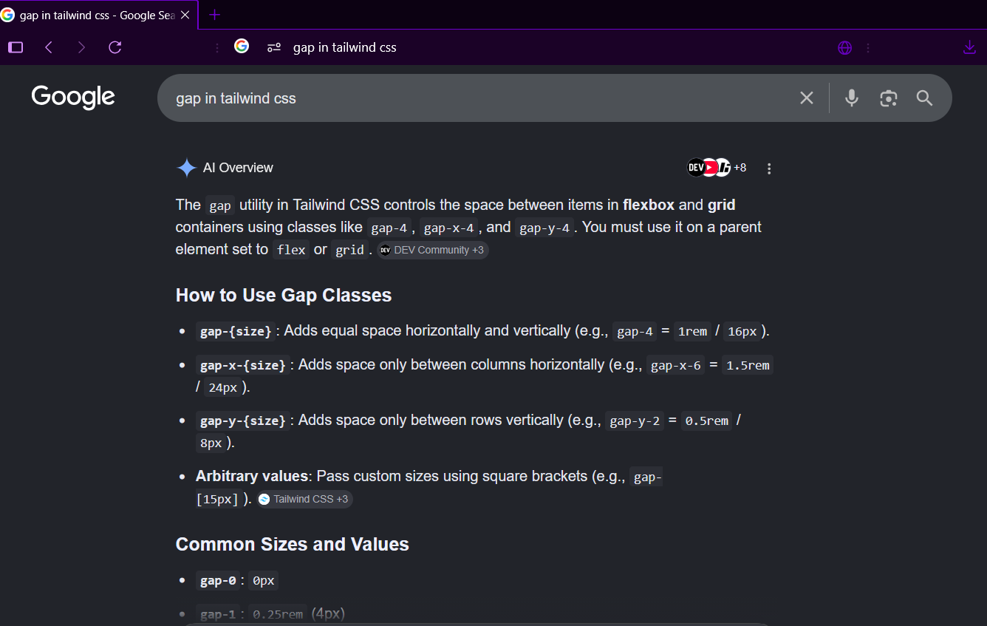
~~ The End ~~

